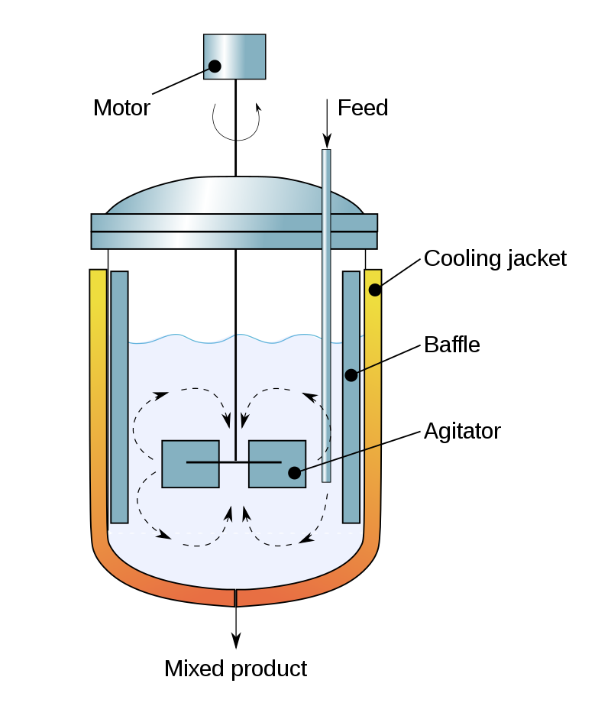

Figure 1: The setup of a common Continuous Stirred-Tank Reactor (CSTR)

$${\dot{C}}_{A}= F ∙\left(C_{A,0} -C_{A}\right)- k_{1}∙C_{A} -k_{3}∙{C_{A}^{2},}_{ }$$

( 1)

$${\dot{C}}_{B}= F ∙C_{B}+{k_{1} ∙ C}_{A}- k_{2}∙C_{B},$$

(2)

${\dot{T}}_{R}= \frac{{k_{1} ∙ C}_{A }∙ H_{R,ab} + k_{2 }∙ C_{B} ∙ H_{R,bc}+ k_{3 }∙ C_{A}^{2} ∙ H_{R,ad} + F ∙ \left( T_{in}- T_{R}\right) + \frac{K_{W} ∙ A_{R} ∙\left( T_{K}- T_{R}\right)}{ρ ∙ c_{p}∙ V_{R}} }{-ρ ∙ c_{p}}$ (3)

$${\dot{T}}_{K}= \frac{ \dot{Q}+ k_{w} ∙A_{R}∙T_{dif}}{m_{k}∙ C_{p,k}}$$

(4)

$$k_{1}= β ∙k_{0,ab} ∙e^{\frac{{-E}_{A,ab}}{T_{R}+273.15}}$$

(5)

$$k_{2}= k_{0,bc} ∙e^{\frac{{-E}_{A,bc}}{T_{R} + 273.15}}$$

(6)

$$k_{3}= k_{0,ad} ∙e^{\frac{{-α ∙ E}_{A,ad}}{T_{R} + 273.15}}$$

(7)

|  |  |
| --- | --- |
| $$k_{0,ab}$$ | 1.287 $e^{12}{ h}^{-1}$ |
| $$k_{0,bc}$$ | 1.287 $e^{12} { h}^{-1}$ |
| $$k_{0,ad}$$ | 9.043 $e^{9}{ h}^{-1}$ |
| $$R_{gas} (Universal gas constant)$$ | 8.31432 $JK^{-1}{mol}^{-1}$ |
| $$E_{A,ab}$$ | 9758.3 $kJ/{mol}^{ }$ |
| $$E_{A,bc}$$ | 9758.3 $kJ/{mol}^{ }$ |
| $$E_{A,ad}$$ | 8560.0 $kJ/{mol}^{ }$ |
| $$H_{R,ab}$$ | 04.20 $kJ/{mol}^{ }A$ |
| $$H_{R,bc}$$ | -11.00 $kJ/{mol}^{ }A$ |
| $$H_{R,ad}$$ | -41.85 $kJ/{mol}^{ }A$ |
| $$R_{ou}$$ | 0.9342 $kg/l$ |
| $c_{p} ($*Specific Heat capacity $)$* | 3.01 $kJ/{kg∙K}^{ }$ |
| $C_{p,k} ($*Coolant heat capacity $)$* | 2.00 $kJ/{kg∙K}^{ }$ |
| $$A_{R} (Area of reactor wall)$$ | 0.215 ${ m}^{2}$ |
| $$V_{R} (Volume of reactor)$$ | 10.01 ${ m}^{3}$ |
| $m_{k}$ $(Coolant mass)$ | 5.0 $kg$ |
| $$T_{in} (Temperature of Inflow)$$ | 130.0 $°C$ |
| $$k_{w}$$ | 4032.0 $kJ/{h{ ∙m}^{2}∙K}^{ }$ |
| $$C_{A,0} (Concentration of A in input Upper$$ $$bound 5.7 lower bound 4.5)$$ | 5.10 |

|  |  |  |  |
| --- | --- | --- | --- |
| **S.No** | **HYPERPARAMETERS** | **HYPERPARAMETERS’ RANGE** | **BEST HYPERPARAMETERS** |
| 1 | NARX Delay Size | $$2≤input_delay_size ≤20$$ | $$4$$ |
| 2 | Activation Function on the Hidden Layers | $$relu, tanh, sigmoid$$ | $$relu$$ |
| 3 | Number of Nodes on Hidden Layers | $$10≤units_nodes_ ≤90$$ | $$30$$ |
| 4 | Number of Hidden Layers | $$2≤hidden_layers ≤10$$ | $$3$$ |
| 5 | Optimizer’s Learning Rate | $$0.1, 0.01, 0.001, 0.0001$$ | $$0.001$$ |
| 6 | Batch Size | $$32, 64, 128, 256$$ | $$64$$ |
| 7 | Optimizer’s Momentum Rate | $$0.3, 0.5, 0.7, 0.9$$ | $$0.5$$ |
| 8 | Tuner Class in KerasTuner | $$RandomSearch Tuner execution_per_trials=10,max_trials=100$$ |  |
| 9 | Loss Objective Function | $$mean_squared_error$$ |  |
| 10 | Epochs | $$300$$ |  |
| 11 | Shuffle of the Data |  |  |

|  |  |  |  |
| --- | --- | --- | --- |
| **S.No** | **NEURAL NETWORK’S PARAMETERS** | **DESCRIPTION** | **PROPERTIES** |
| 1 | Input Data for Training (NARX) | $$X_train$$ | $$Shape: (3000, 24)$$ |
| 2 | Input Data for Testing (NARX) | $$X_test$$ | $$Shape: (596, 24)$$ |
| 3 | Target Data for Training | $$y_train$$ | $$Shape: (3000, 4)$$ |
| 4 | Target Data for Testing | $$y_test$$ | $$Shape: (596, 4)$$ |
| 5 | Keras Optimizer Used | $$Gradient descent \left(with momentum\right)optimizer(SGD)$$ | $$tf.keras.optimizers.SGD()$$ |
| 6 | Callbacks | $$EarlyStopping, CSVLogger and TensorBoard$$ |  |
| 7 | Epochs | $$10000$$ |  |
| 8 | Loss Objective Function | $$mean_squared_error$$ |  |
| 9 | Loss Metrics | $$mean_squared_error, accuracy, RootMeanSquaredError$$ |  |
| 10 | Train and Test Split |  |  |

|  |  |  |  |
| --- | --- | --- | --- |
| **S.No** | **PGNN Constraints** | **DESCRIPTION** |  |
| 1 | Concentration of reactant A ($C_{A }$) greater than 0 | $$C_{A }≥0$$ | $$tf.math.reduce_sum(tf.nn.relu(ca_PGNN))$$ |
| 2 | Concentration of reactant B ($C_{B }$) greater than 0 | $$C_{B }≥0$$ | $$tf.math.reduce_sum(tf.nn.relu(cb_PGNN))$$ |
| 3 | Product of Rate of Change of Heat Flow $\frac{∂\dot{Q}}{∂t}$ and Rate of Change of Temperature of Jacket $\frac{{∂T}_{K}}{∂t}$ | $$\frac{∂\dot{Q}}{∂t}∙\frac{{∂T}_{K}}{∂t}$$ | $$tf.math.reduce_sum(tf.nn.relu(-product_q_dot_and_jacket_temperature))$$ |